**Task A**

a)

M=10000

n=16

XSamples=matrix(rep(0,n*M),M,n)

b)

for(j in 1:M){XSamples[j,]=rexp(n,rate=.1)}

c)

Xbars=apply(XSamples,1,mean)

Sdn=apply(XSamples,1,sd)

d)

Tn=sqrt(n)*((Xbars-10)/Sdn)

e)

> mean(Tn)

[1] -0.2915269

> var(Tn)

[1] 1.596319

> sd(Tn)

[1] 1.263455

> summary(Tn)

Min. 1st Qu. Median Mean 3rd Qu. Max.

-12.2020 -0.9391 -0.0847 -0.2915 0.5789 4.3260

f)

hist(Tn, nclass=30, freq=F, main="Sampling Distribution of Tn when n=16 and lambda

=0.1")

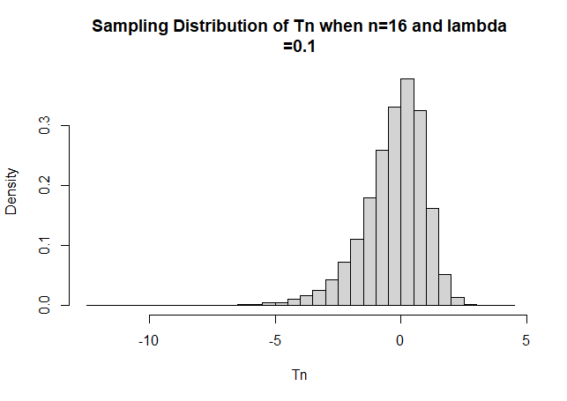

g)

start<-min(Tn)-5*sd(Tn)

end<-max(Tn)+5*sd(Tn)

xx<-seq(start, end, length=200)

lines(xx, dnorm(xx, mean(Tn), sd(Tn)), col=2, lwd=2)

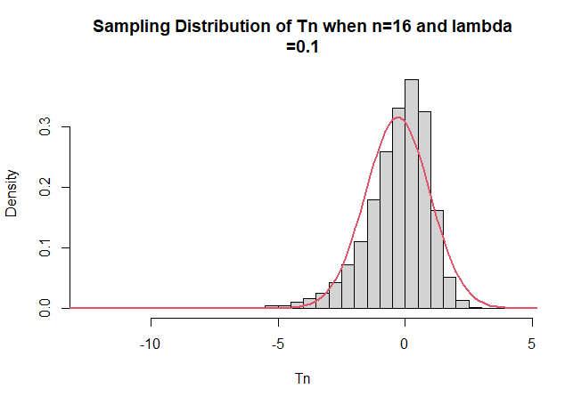

h)

>M=10000

> n=32

> XSamples=matrix(rep(0,n*M),M,n)

> for(j in 1:M)

{XSamples[j,]=rexp(n,rate=.1)}

> Xbars=apply(XSamples,1,mean)

> Sdn=apply(XSamples,1,sd)

> Tn=sqrt(n)*((Xbars-10)/Sdn)

> mean(Tn)

[1] -0.1874147

> var(Tn)

[1] 1.292809

> sd(Tn)

[1] 1.137018

> summary(Tn)

Min. 1st Qu. Median Mean 3rd Qu. Max.

-7.46872 -0.81567 -0.06935 -0.18741 0.59142 3.13370

> hist(Tn, nclass=30, freq=F, main="Sampling Distribution of Tn when n=32 and lambda

+ =0.1")

> start<-min(Tn)-5*sd(Tn)

> end<-max(Tn)+5*sd(Tn)

> xx<-seq(start, end, length=200)

> lines(xx, dnorm(xx, mean(Tn), sd(Tn)), col=2, lwd=2)

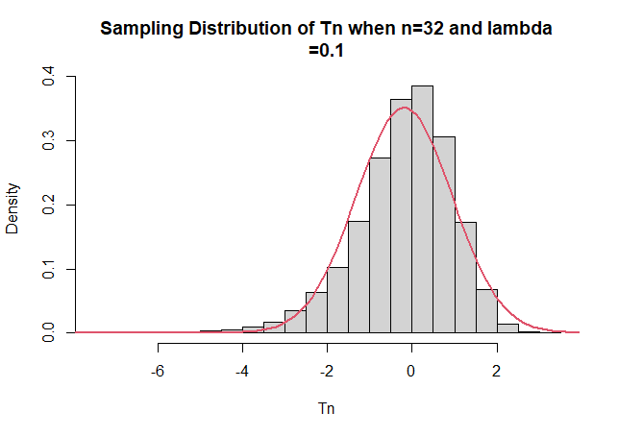

> M=10000

> n=64

> XSamples=matrix(rep(0,n*M),M,n)

>

> for(j in 1:M)

{XSamples[j,]=rexp(n,rate=.1)}

> Xbars=apply(XSamples,1,mean)

> Sdn=apply(XSamples,1,sd)

> Tn=sqrt(n)*((Xbars-10)/Sdn)

> mean(Tn)

[1] -0.1283224

> var(Tn)

[1] 1.135431

> sd(Tn)

[1] 1.065566

> summary(Tn)

Min. 1st Qu. Median Mean 3rd Qu. Max.

-5.15066 -0.78342 -0.04588 -0.12832 0.61862 3.42413

> hist(Tn, nclass=30, freq=F, main="Sampling Distribution of Tn when n=64 and lambda

+ =0.1")

> start<-min(Tn)-5*sd(Tn)

> end<-max(Tn)+5*sd(Tn)

> xx<-seq(start, end, length=200)

> lines(xx, dnorm(xx, mean(Tn), sd(Tn)), col=2, lwd=2)

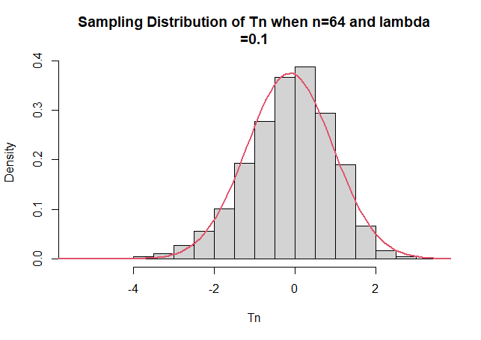

> M=10000

> n=128

> XSamples=matrix(rep(0,n*M),M,n)

> for(j in 1:M)

{XSamples[j,]=rexp(n,rate=.1)}

> Xbars=apply(XSamples,1,mean)

> Sdn=apply(XSamples,1,sd)

> Tn=sqrt(n)*((Xbars-10)/Sdn)

> mean(Tn)

[1] -0.09789581

> var(Tn)

[1] 1.070067

> sd(Tn)

[1] 1.03444

> summary(Tn)

Min. 1st Qu. Median Mean 3rd Qu. Max.

-5.62833 -0.75474 -0.04975 -0.09790 0.61580 3.12192

> hist(Tn, nclass=30, freq=F, main="Sampling Distribution of Tn when n=128 and lambda

+ =0.1")

> start<-min(Tn)-5*sd(Tn)

> end<-max(Tn)+5*sd(Tn)

> xx<-seq(start, end, length=200)

> lines(xx, dnorm(xx, mean(Tn), sd(Tn)), col=2, lwd=2)

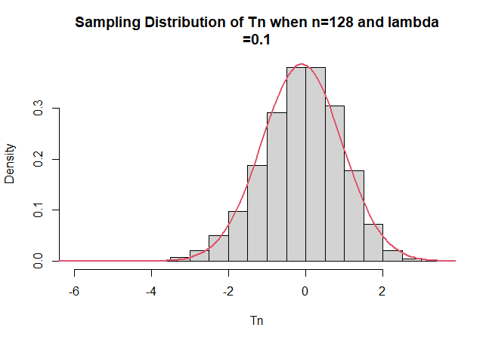

> M=10000

> n=256

> XSamples=matrix(rep(0,n*M),M,n)

> for(j in 1:M)

{XSamples[j,]=rexp(n,rate=.1)}

> Xbars=apply(XSamples,1,mean)

> Sdn=apply(XSamples,1,sd)

> Tn=sqrt(n)*((Xbars-10)/Sdn)

> mean(Tn)

[1] -0.06841728

> var(Tn)

[1] 1.028279

> sd(Tn)

[1] 1.014041

> summary(Tn)

Min. 1st Qu. Median Mean 3rd Qu. Max.

-4.39639 -0.71635 -0.03155 -0.06842 0.63038 3.56198

> hist(Tn, nclass=30, freq=F, main="Sampling Distribution of Tn when n=256 and lambda

+ =0.1")

> start<-min(Tn)-5*sd(Tn)

> end<-max(Tn)+5*sd(Tn)

> xx<-seq(start, end, length=200)

> lines(xx, dnorm(xx, mean(Tn), sd(Tn)), col=2, lwd=2)

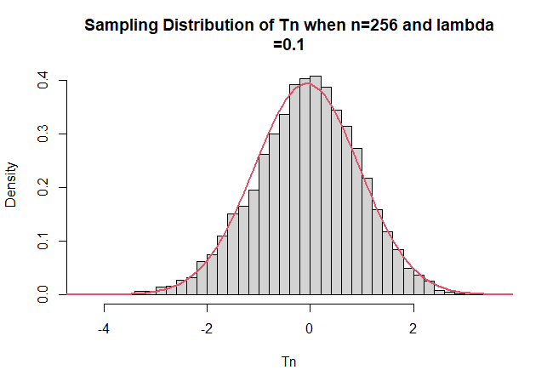

> M=10000

> n=1280

> XSamples=matrix(rep(0,n*M),M,n)

> for(j in 1:M)

{XSamples[j,]=rexp(n,rate=.1)}

> Xbars=apply(XSamples,1,mean)

> Sdn=apply(XSamples,1,sd)

> Tn=sqrt(n)*((Xbars-10)/Sdn)

> mean(Tn)

[1] -0.02888943

> var(Tn)

[1] 1.021304

> sd(Tn)

[1] 1.010596

> summary(Tn)

Min. 1st Qu. Median Mean 3rd Qu. Max.

-3.758834 -0.695962 -0.007472 -0.028889 0.663788 4.026369

> hist(Tn, nclass=30, freq=F, main="Sampling Distribution of Tn when n=1280 and lambda

+ =0.1")

> start<-min(Tn)-5*sd(Tn)

> end<-max(Tn)+5*sd(Tn)

> xx<-seq(start, end, length=200)

> lines(xx, dnorm(xx, mean(Tn), sd(Tn)), col=2, lwd=2)

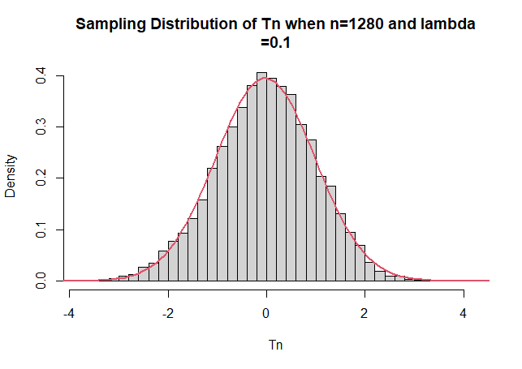

The higher the sample size (n), the closer it is to normal distribution

**Task B**

a)

> M=10000

> n=8

> XSamples=matrix(rep(0,n*M),M,n)

> for(j in 1:M)

{XSamples[j , ]<- rnorm(n, 10, 10)}

> Xbars=apply(XSamples,1,mean)

> Sdn=apply(XSamples,1,sd)

> Tn=sqrt(n)*((Xbars-10)/Sdn)

> mean(Tn)

[1] -0.002626264

> var(Tn)

[1] 1.434022

> sd(Tn)

[1] 1.197507

> summary(Tn)

Min. 1st Qu. Median Mean 3rd Qu. Max.

-8.362012 -0.724729 -0.003779 -0.002626 0.708129 8.064506

> hist(Tn, nclass=30, freq=F, main="Sampling Distribution of Tn when n=8 and lambda

+ =0.1")

> start<-min(Tn)-5*sd(Tn)

> end<-max(Tn)+5*sd(Tn)

> xx<-seq(start, end, length=200)

> lines(xx, dnorm(xx, mean(Tn), sd(Tn)), col=2, lwd=2)

> lines(xx, dt(xx, n-1), col=4, lwd=2)

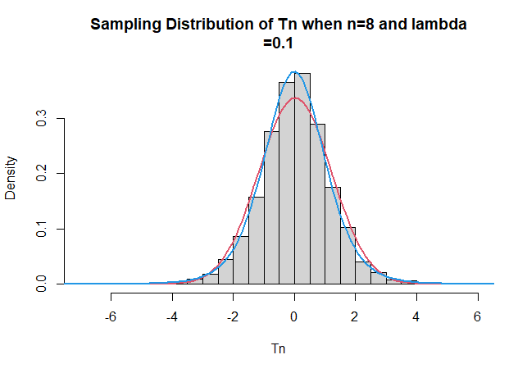

> M=10000

> n=10

> XSamples=matrix(rep(0,n*M),M,n)

> for(j in 1:M)

{XSamples[j , ]<- rnorm(n, 10, 10)}

> Xbars=apply(XSamples,1,mean)

> Sdn=apply(XSamples,1,sd)

> Tn=sqrt(n)*((Xbars-10)/Sdn)

> mean(Tn)

[1] -0.003624257

> var(Tn)

[1] 1.289106

> sd(Tn)

[1] 1.135388

> summary(Tn)

Min. 1st Qu. Median Mean 3rd Qu. Max.

-7.200056 -0.700894 0.009750 -0.003624 0.715724 5.542437

> hist(Tn, nclass=30, freq=F, main="Sampling Distribution of Tn when n=10 and lambda

+ =0.1")

> start<-min(Tn)-5*sd(Tn)

> end<-max(Tn)+5*sd(Tn)

> xx<-seq(start, end, length=200)

> lines(xx, dnorm(xx, mean(Tn), sd(Tn)), col=2, lwd=2)

> lines(xx, dt(xx, n-1), col=4, lwd=2)

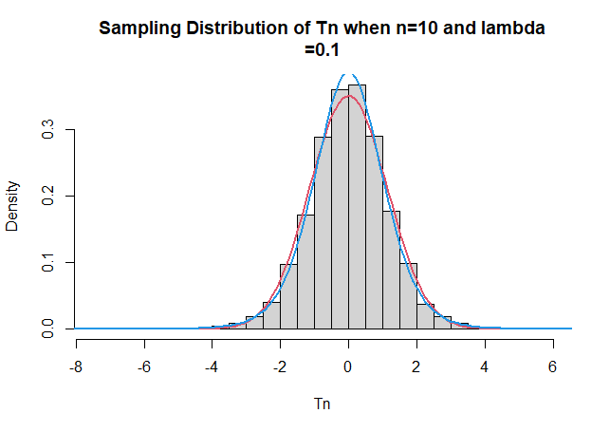

> M=10000

> n=16

> XSamples=matrix(rep(0,n*M),M,n)

> for(j in 1:M)

{XSamples[j , ]<- rnorm(n, 10, 10)}

> Xbars=apply(XSamples,1,mean)

> Sdn=apply(XSamples,1,sd)

> Tn=sqrt(n)*((Xbars-10)/Sdn)

> mean(Tn)

[1] 0.01515732

> var(Tn)

[1] 1.128024

> sd(Tn)

[1] 1.062085

> summary(Tn)

Min. 1st Qu. Median Mean 3rd Qu. Max.

-4.75047 -0.66648 0.01530 0.01516 0.69117 5.14867

> hist(Tn, nclass=30, freq=F, main="Sampling Distribution of Tn when n=16 and lambda

+ =0.1")

> start<-min(Tn)-5*sd(Tn)

> end<-max(Tn)+5*sd(Tn)

> xx<-seq(start, end, length=200)

> lines(xx, dnorm(xx, mean(Tn), sd(Tn)), col=2, lwd=2)

> lines(xx, dt(xx, n-1), col=4, lwd=2)

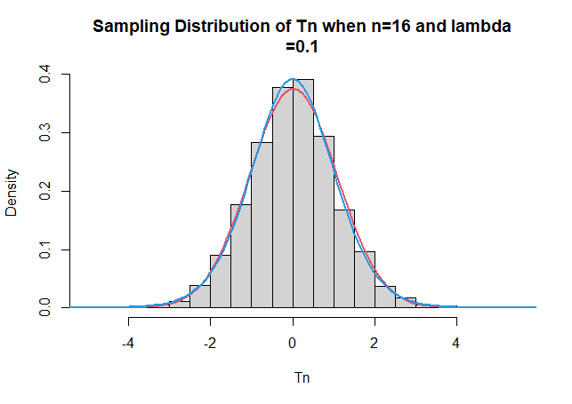

> M=10000

> n=32

> XSamples=matrix(rep(0,n*M),M,n)

> for(j in 1:M)

{XSamples[j , ]<- rnorm(n, 10, 10)}

> Xbars=apply(XSamples,1,mean)

> Sdn=apply(XSamples,1,sd)

> Tn=sqrt(n)*((Xbars-10)/Sdn)

> mean(Tn)

[1] 0.01336793

> var(Tn)

[1] 1.099169

> sd(Tn)

[1] 1.048413

> summary(Tn)

Min. 1st Qu. Median Mean 3rd Qu. Max.

-4.519853 -0.673548 0.007503 0.013368 0.715361 4.700435

> hist(Tn, nclass=30, freq=F, main="Sampling Distribution of Tn when n=32 and lambda

+ =0.1")

> start<-min(Tn)-5*sd(Tn)

> end<-max(Tn)+5*sd(Tn)

> xx<-seq(start, end, length=200)

> lines(xx, dnorm(xx, mean(Tn), sd(Tn)), col=2, lwd=2)

> lines(xx, dt(xx, n-1), col=4, lwd=2)

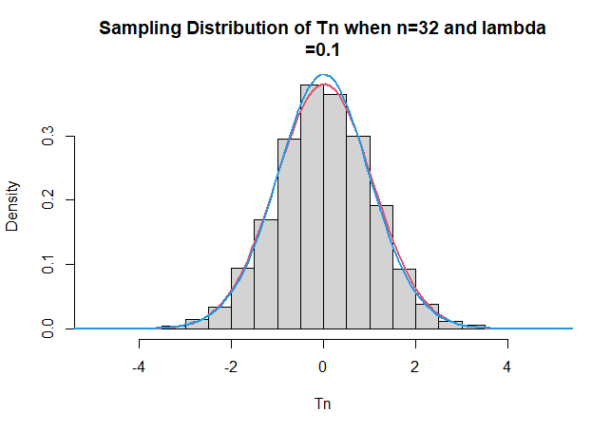

> M=10000

> n=48

> XSamples=matrix(rep(0,n*M),M,n)

> for(j in 1:M)

{XSamples[j , ]<- rnorm(n, 10, 10)}

> Xbars=apply(XSamples,1,mean)

> Sdn=apply(XSamples,1,sd)

> Tn=sqrt(n)*((Xbars-10)/Sdn)

> mean(Tn)

[1] -0.01144452

> var(Tn)

[1] 1.044808

> sd(Tn)

[1] 1.022159

> summary(Tn)

Min. 1st Qu. Median Mean 3rd Qu. Max.

-4.36361 -0.68434 -0.01581 -0.01145 0.65898 4.36857

> hist(Tn, nclass=30, freq=F, main="Sampling Distribution of Tn when n=48 and lambda

+ =0.1")

> start<-min(Tn)-5*sd(Tn)

> end<-max(Tn)+5*sd(Tn)

> xx<-seq(start, end, length=200)

> lines(xx, dnorm(xx, mean(Tn), sd(Tn)), col=2, lwd=2)

> lines(xx, dt(xx, n-1), col=4, lwd=2)

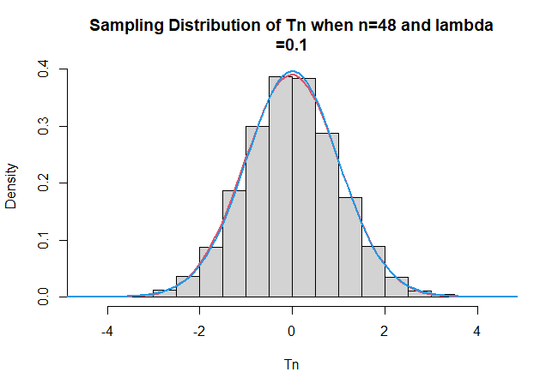

> M=10000

> n=96

> XSamples=matrix(rep(0,n*M),M,n)

> for(j in 1:M)

{XSamples[j , ]<- rnorm(n, 10, 10)}

> Xbars=apply(XSamples,1,mean)

> Sdn=apply(XSamples,1,sd)

> Tn=sqrt(n)*((Xbars-10)/Sdn)

> mean(Tn)

[1] -0.01746789

> var(Tn)

[1] 1.042503

> sd(Tn)

[1] 1.021031

> summary(Tn)

Min. 1st Qu. Median Mean 3rd Qu. Max.

-4.04602 -0.69386 -0.01328 -0.01747 0.66539 4.12047

> hist(Tn, nclass=30, freq=F, main="Sampling Distribution of Tn when n=96 and lambda

+ =0.1")

> start<-min(Tn)-5*sd(Tn)

> end<-max(Tn)+5*sd(Tn)

> xx<-seq(start, end, length=200)

> lines(xx, dnorm(xx, mean(Tn), sd(Tn)), col=2, lwd=2)

> lines(xx, dt(xx, n-1), col=4, lwd=2)

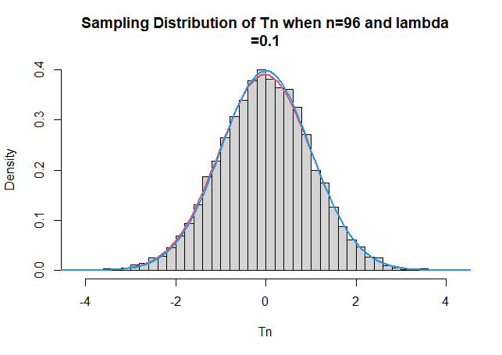

Similarly these graphs show, the higher the sample size, the closer the sample distribution is to normal and t distribution.